CSC 3320 HW 2

Dong Yoo

1. Grep is the “basic” way to search for certain strings in a file/files, which allows for a few select regex. Egrep has the same functions as grep but has more special characters that can be used as regex. Fgrep is like grep but with no regex being allowed.
2. The tar command is used to compress files in UNIX, and multiple files can be compressed into one with something like $tar -cvf example.tar /home/csc3320
3. The utilities that can separate fields are as follows: $awk and $sort. The default separator is blank space, but it can be changed in awk with -F: (to use : as separator) and in sort with -t:.
4. The sort command sorts a file in ascending or descending order based on a specific field(s). -r sorts by descending instead of ascending, -b ignores leading blanks, -f ignores case for letters, -M is month sort, and -n is sort by number. For example, $sort -r 3 example.txt would sort the lines by the third field in descending order.
5. Hello Worl!!!
6. A) any line with more than one field will have their fifth field printed

b) the first field of the fifth line onwards

c) prints out the entire file

d) prints the first field of every line

1. good
2. $awk ‘/+$/’ example.txt
3. First 5 lines is $sed -e ‘1,5d’ foo.txt, last 5 lines is $head -n -5 foo.txt
4. Function: Output line 3 with its line number and a colon

Output: 3:When everything seemed so clear.

1. Function: If a line has “ing”, then it prints the line number and the first word of the line with a colon in between

Output: 1: Wish

3: When

4: Now

1. Function: First, print start to scan file. Next, prints the first field of each line, a comma, then the last field of each line. Finally, prints END- and the filename.

Output: Start to scan file

Wish, is

Strong,, days

When, clear

Now, all…

END- float

1. Function: The sed replaces all white space with a tab

Output: Wish I was floating …

… here at all… (shortened so it doesn’t take up entire doc)

1. Function: Searches for lines containing BEGIN from all awk files in the directory, which is h2.awk, and the BEGIN will be highlighted

Output: BEGIN{print “Start to scan file”}

1. This creates a directory test, and directories test1 and test2 inside test, and a text file testt.txt inside test, with text “This is a test file”. Then, it goes inside test, and duplicates all directories (test1 and test2) with the extension .bak.
2. First, I created the three directories that the files will go into (although I deleted pdf and docx for csv and c pretty soon)



Next, I copied each file I found created before Feb 6 to the respective directory



Then I sorted each file by date using $ls -lt

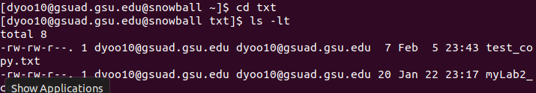

I then created the tar file of txt, c, and csv



Finally, I created archive.tar by throwing the other 3 tar files in there

